**THE MOVIE TICKETING BOT**

**Project Report**

**Submitted by:**

**MUTHAZHAGI.C,**

B.Tech-Information Technonogy,

Coimbatore Institute of Technology,

Coimbatore-14.

**TABLE OF CONTENTS**

**Sl. No.** **Description**  **Page No**

**1 INTRODUCTION** **3**

1.1 Overview 3

1.2 Purpose 4

**2 LITERATURE SURVEY** **5**

2.1 Existing problem 5

2.2 Proposed solution 5

**3 THEORITICAL ANALYSIS** **5**

3.1 Block diagram 5

3.2 Hardware / Software designing 6

**4 EXPERIMENTAL INVESTIGATIONS** **12**

**5 FLOWCHART** **15**

**6 RESULT**  **17**

**7 ADVANTAGES & DISADVANTAGES** **20**

**8 APPLICATIONS** **20**

**9 CONCLUSION** **21**

**10 FUTURE SCOPE** **21**

**11 BIBILOGRAPHY** **21**

**APPENDIX** **22**

A. Source code 22

**INTRODUCTION**

**1.1 Overview**

Recently, new tools designed to simplify the interaction between humans and computers have hit the market: Chatbots or Virtual Assistants. In banking, chatbots and virtual assistants are some of the industry’s newest tools designed to simplify the interaction between humans and computers.

A chatbot is often described as one of the most advanced and promising expressions of interaction between humans and machines. However, from a technological point of view, a chatbot only represents the natural evolution of a Question Answering system leveraging Natural Language Processing (NLP). Formulating responses to questions in natural language is one of the most typical Examples of Natural Language Processing applied in various enterprises’ end-use applications. A chatbot is an artificial intelligence (AI) software that can simulate a conversation (or a chat) with a user in natural language through messaging applications, websites, mobile apps or through the telephone.

**Tools used/needed:**

* IBM Watson Assistant
* Node-Red

**IBM Watson Assistant:**

IBM Watson Assistant is a smarter AI assistant that helps customers with fast, straightforward and accurate answers to their questions, across any application, device or channel. By automating responses to common inquiries, Watson Assistant reduces the burden on agents and the risk of disruption during peak times. This lets agents focus on complex use cases – not repetitive responses – and helps customers resolve issues day or night.

Also, it provides fast, consistent responses across any channel by using the same underlying technology for voice and text-based interactions – not multiple point systems. Keep interactions intuitive and repeatable, using consistent features and capabilities to help customers resolve issues quickly and effectively.

**Features:**

* Anyone can build
* Powered by natural language understanding (NLU)
* Connect to anything
* Deploy anywhere
* Maintain control and ownership of your data and scale across your business with a trusted, secure partner
* Try for Free

**Node RED:**

Node-RED is a programming tool for wiring together hardware devices, APIs and online services in new and interesting ways. It provides a browser-based editor that makes it easy to wire together flows using the wide range of nodes in the palette that can be deployed to its runtime in a single-click.

**Features:**

* Flow-based Programming
* Runtime/Editor
* Try for Free

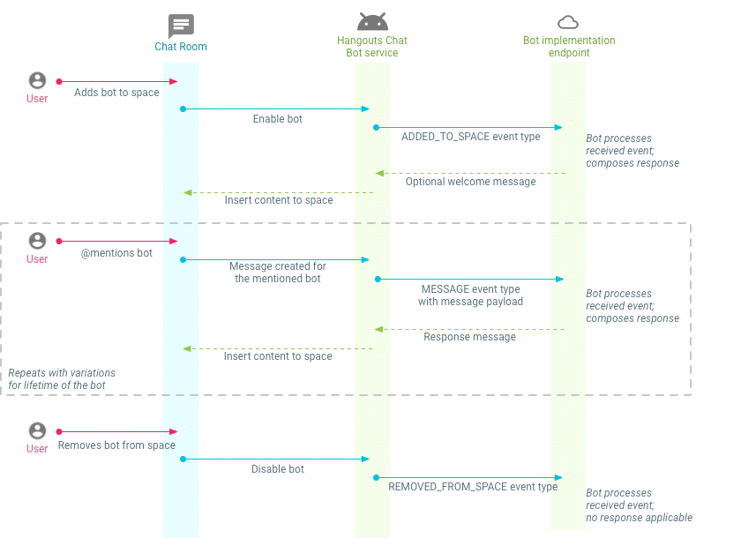

**1.2 Purpose**

The chat bot should be able to give the list of movies available, able to show different show timings, show the availability of tickets, prices and should be in a position to book tickets.

**LITERATURE SURVEY**

**2.1 Existing problem**

The current system includes going to a website or an mobile app and login then select the movie and seats then we have to book the seat(s). The problem here is that the traditional way of booking will not have an interactive way of communication like Natural Language, Speech to Text and text to Speech based booking and even a friendly manner.

**2.2 Proposed solution**

To create an interactive bot using IBM Cloud and Node-Red. IBM Watson Assistant is used for creating a chat box and Node-Red as a tool to deploy the bot. chatbot using Watson assistant. The chat bot should be able to give the list of movies available, able to show different show timings, show the availability of tickets, prices and should be in a position to book tickets.

**THEORITICAL ANALYSIS**

**Block diagram**

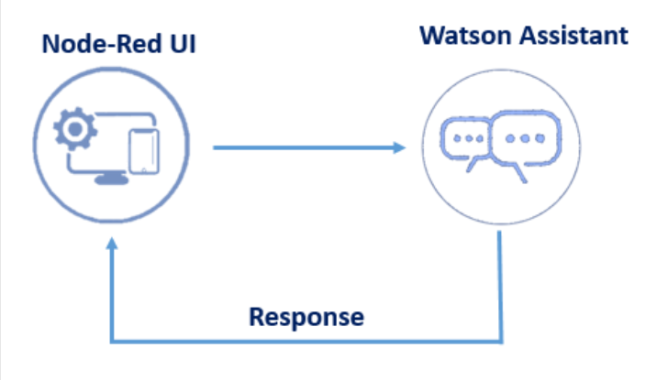

Fig 1 - Block Diagram

**Hardware / Software designing**

**Creating a Chatbot using IBM Watson Assistant:**

**Procedure:**

Building Chatbot:

Building a chatbot using Watson assistant

Step 1: Login to IBM Account-https://cloud.ibm.com/login

Step 2: Create Watson Assistant Service-Create Watson assistant service by going to the catalog

Step 3: Create Intents-the following intents are created

* Greetings
* Movies availability
* Book tickets
* Enquiry

Step 4: Create Entities-Create multiple entities that include all the keywords that are present in the respective intents.

Step 5: Use System Entities-Make use of system entities that can be used to detect date, time, numbers which are useful while extracting information

Step 6: Create Dialog-Add nodes for Greetings, Enquiry, availability of movies, Booking of tickets. In booking tickets, make use of slots.

**Building Node-Red Application**

Create node-red service by going to the catalog.

**Step 1: Login to IBM Account-https://cloud.ibm.com/login**

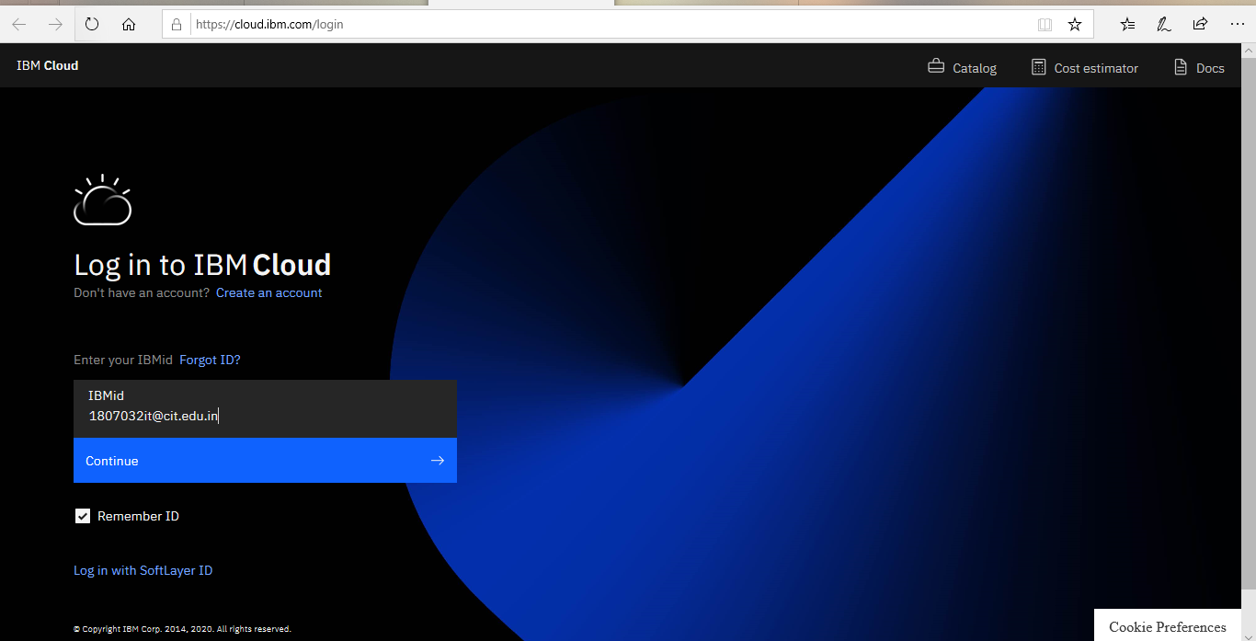

Step 2: Create Watson Assistant Service

Then go resource list and click watson assistant

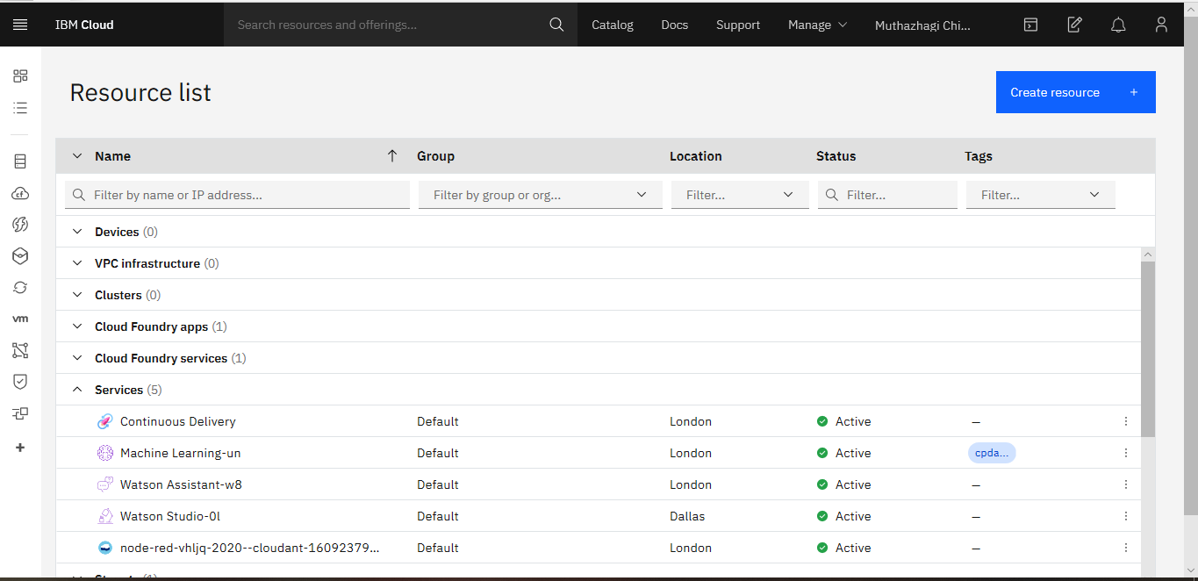

Click Launch Assistant 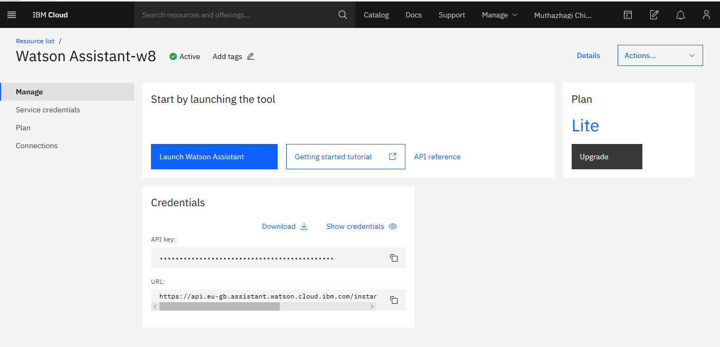

Step3: Create intents

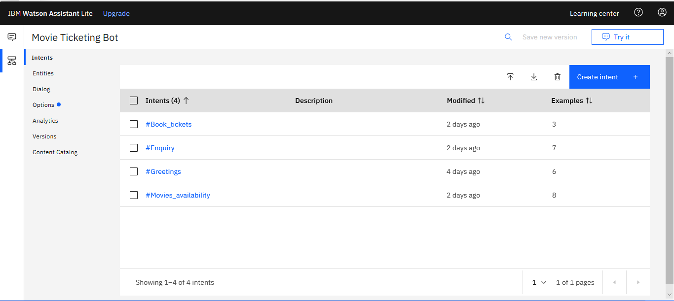

Step 4: Create Entities

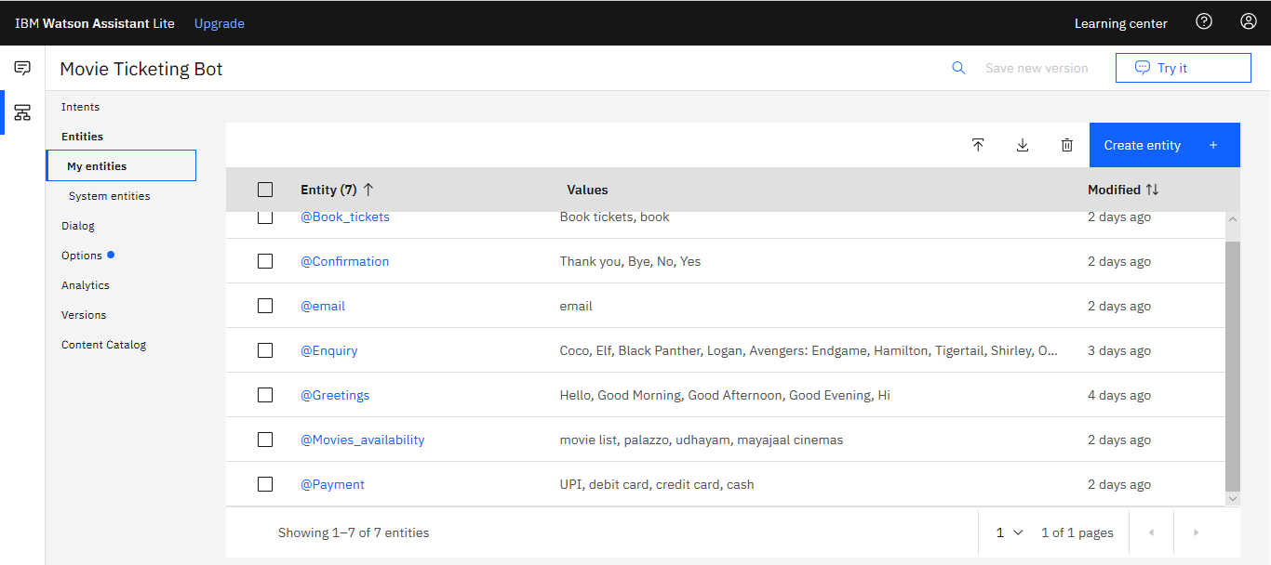

Step 5: Use System Entities

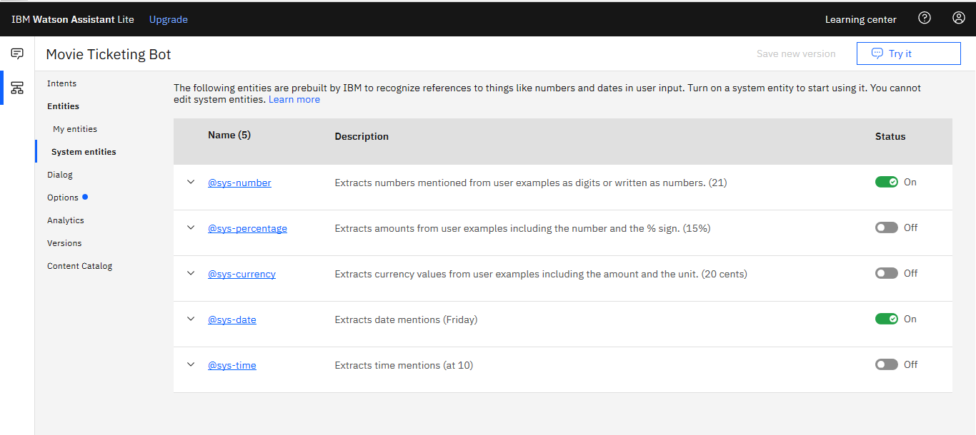

Step 6: Create Dialog

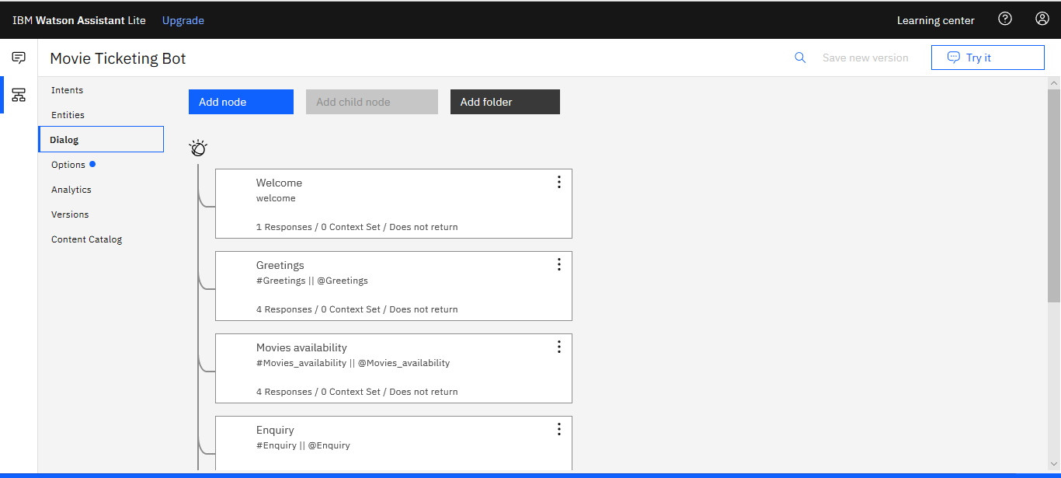

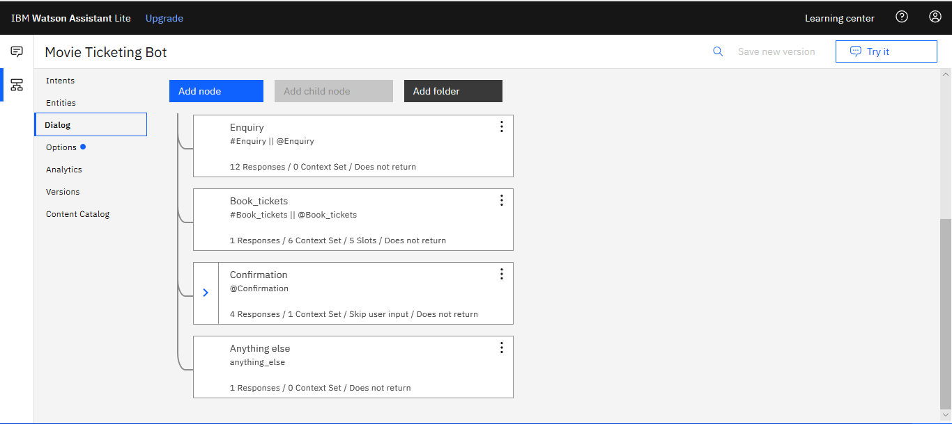

And try it testing purpose

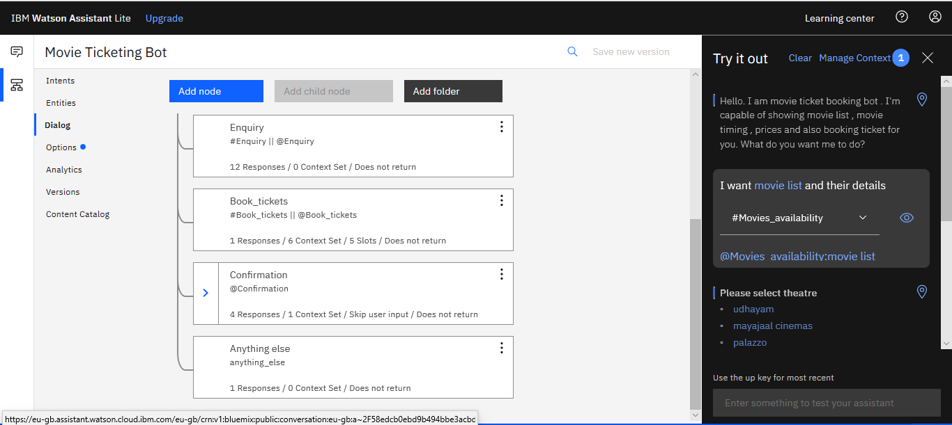

**Creating a Node RED Flow:**

Step 1: Create Node-Red Service

Step 2: Integrate Node-Red to Watson Assistant

Go to Catalog and search for the Node-Red App in Software.

Select Lite plan and select Get Started and Create button.

Click Deploy your App

Click Visit App URL

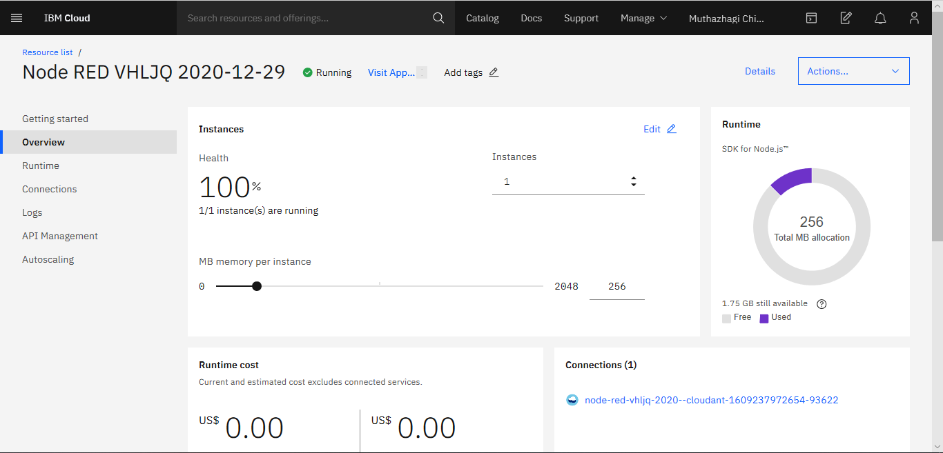

Follow the steps as desires and click finish

Then Click Go to tour Node-Red flow editor

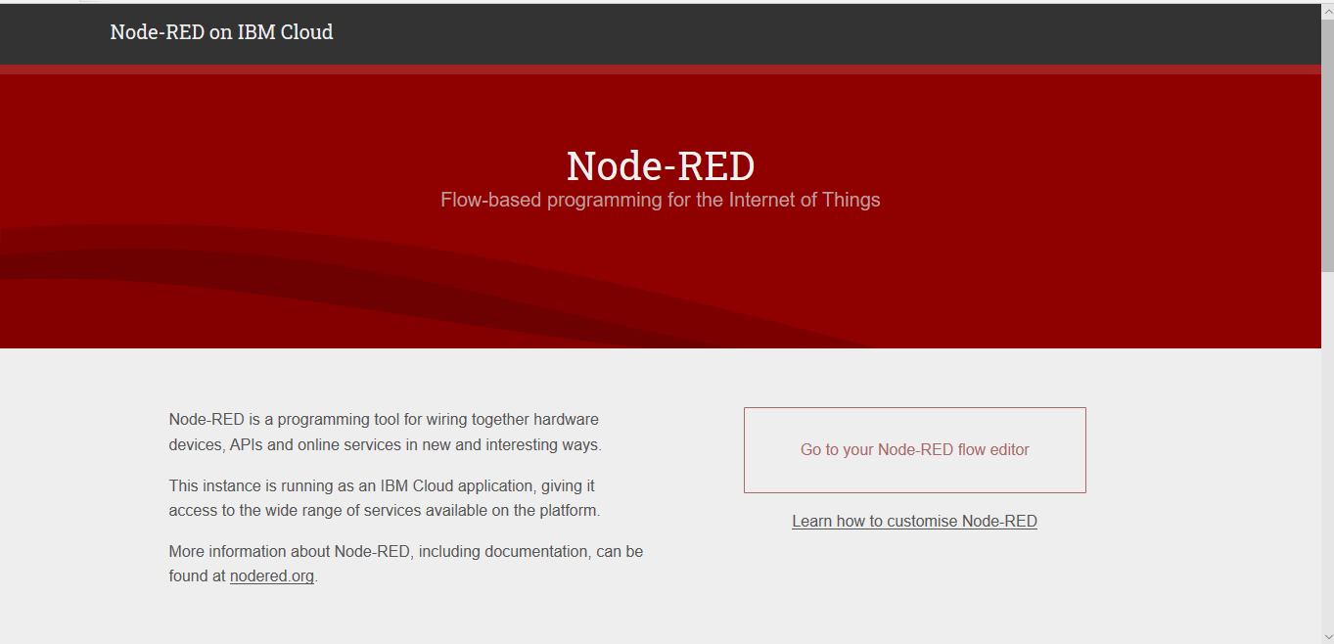

Drag and drop the pallets and connect them as per the requirement and

Configure the I/P and O/P group with a same new group.

Create a form to give input

Create a function pallet to load the message to assistant with the following property

msg.payload= msg.payload.User

return msg;

Create a assistant pallet

Now in assistant pallet add the required credentials like API key etc., and click done

Use a Switch pallet as output to the switch and use 2 switches for options and otherwise

Use Options Parser for option switch and Text response parser for otherwise switch with the following properties

if(msg.payload.output.generic[0].response_type=="option"){

Var="str";

str=msg.payload.output.generic[0].title;

for(var i=0;i<msg.payload.output.generic[0].options.length;i++)

{

str=str+msg.payload.output.generic[0].options[i].label+" "

}

msg.payload=str;

}

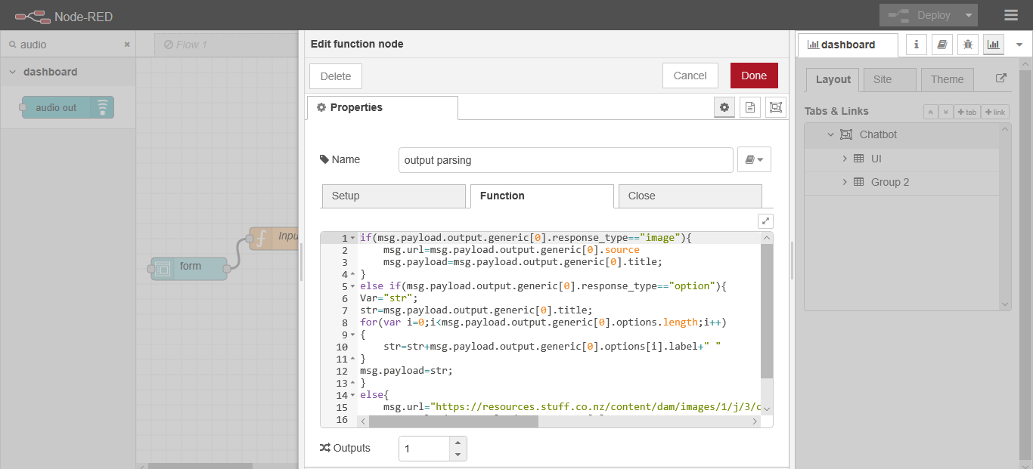

Click deploy

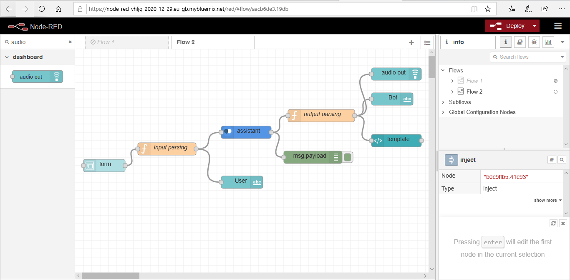

**EXPERIMENTAL INVESTIGATIONS**

In IBM Watson Click on Try it out and test the bot for its performance

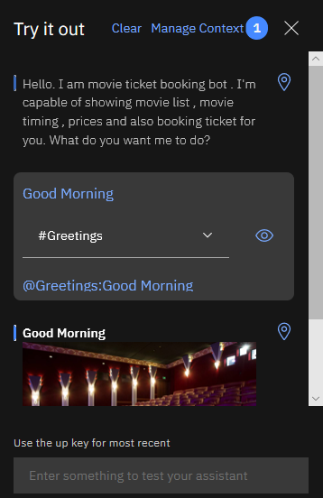

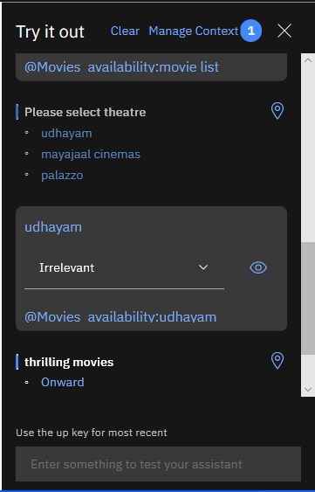

Click on integrations and check the chat using Preview Link

Try the bot again in this web view

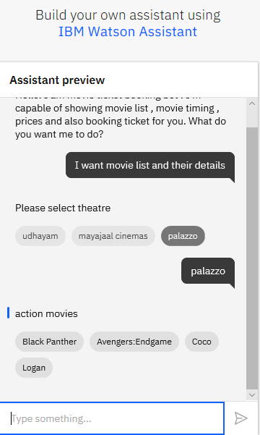

Click on Dashboard and click the popup icon to display the dashboard in Node-Red

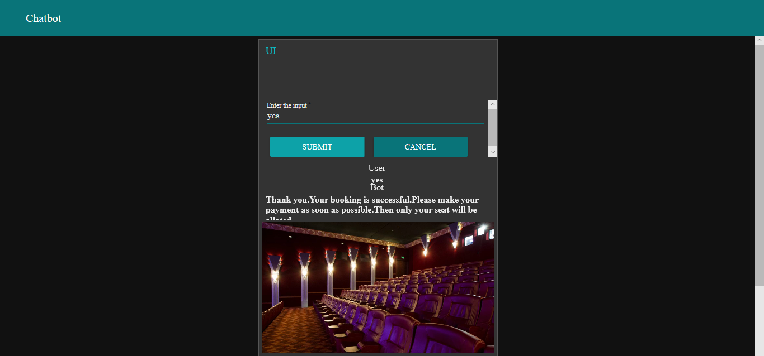

Give various inputs and verify the results

**FLOWCHART**

**Complete Flow**

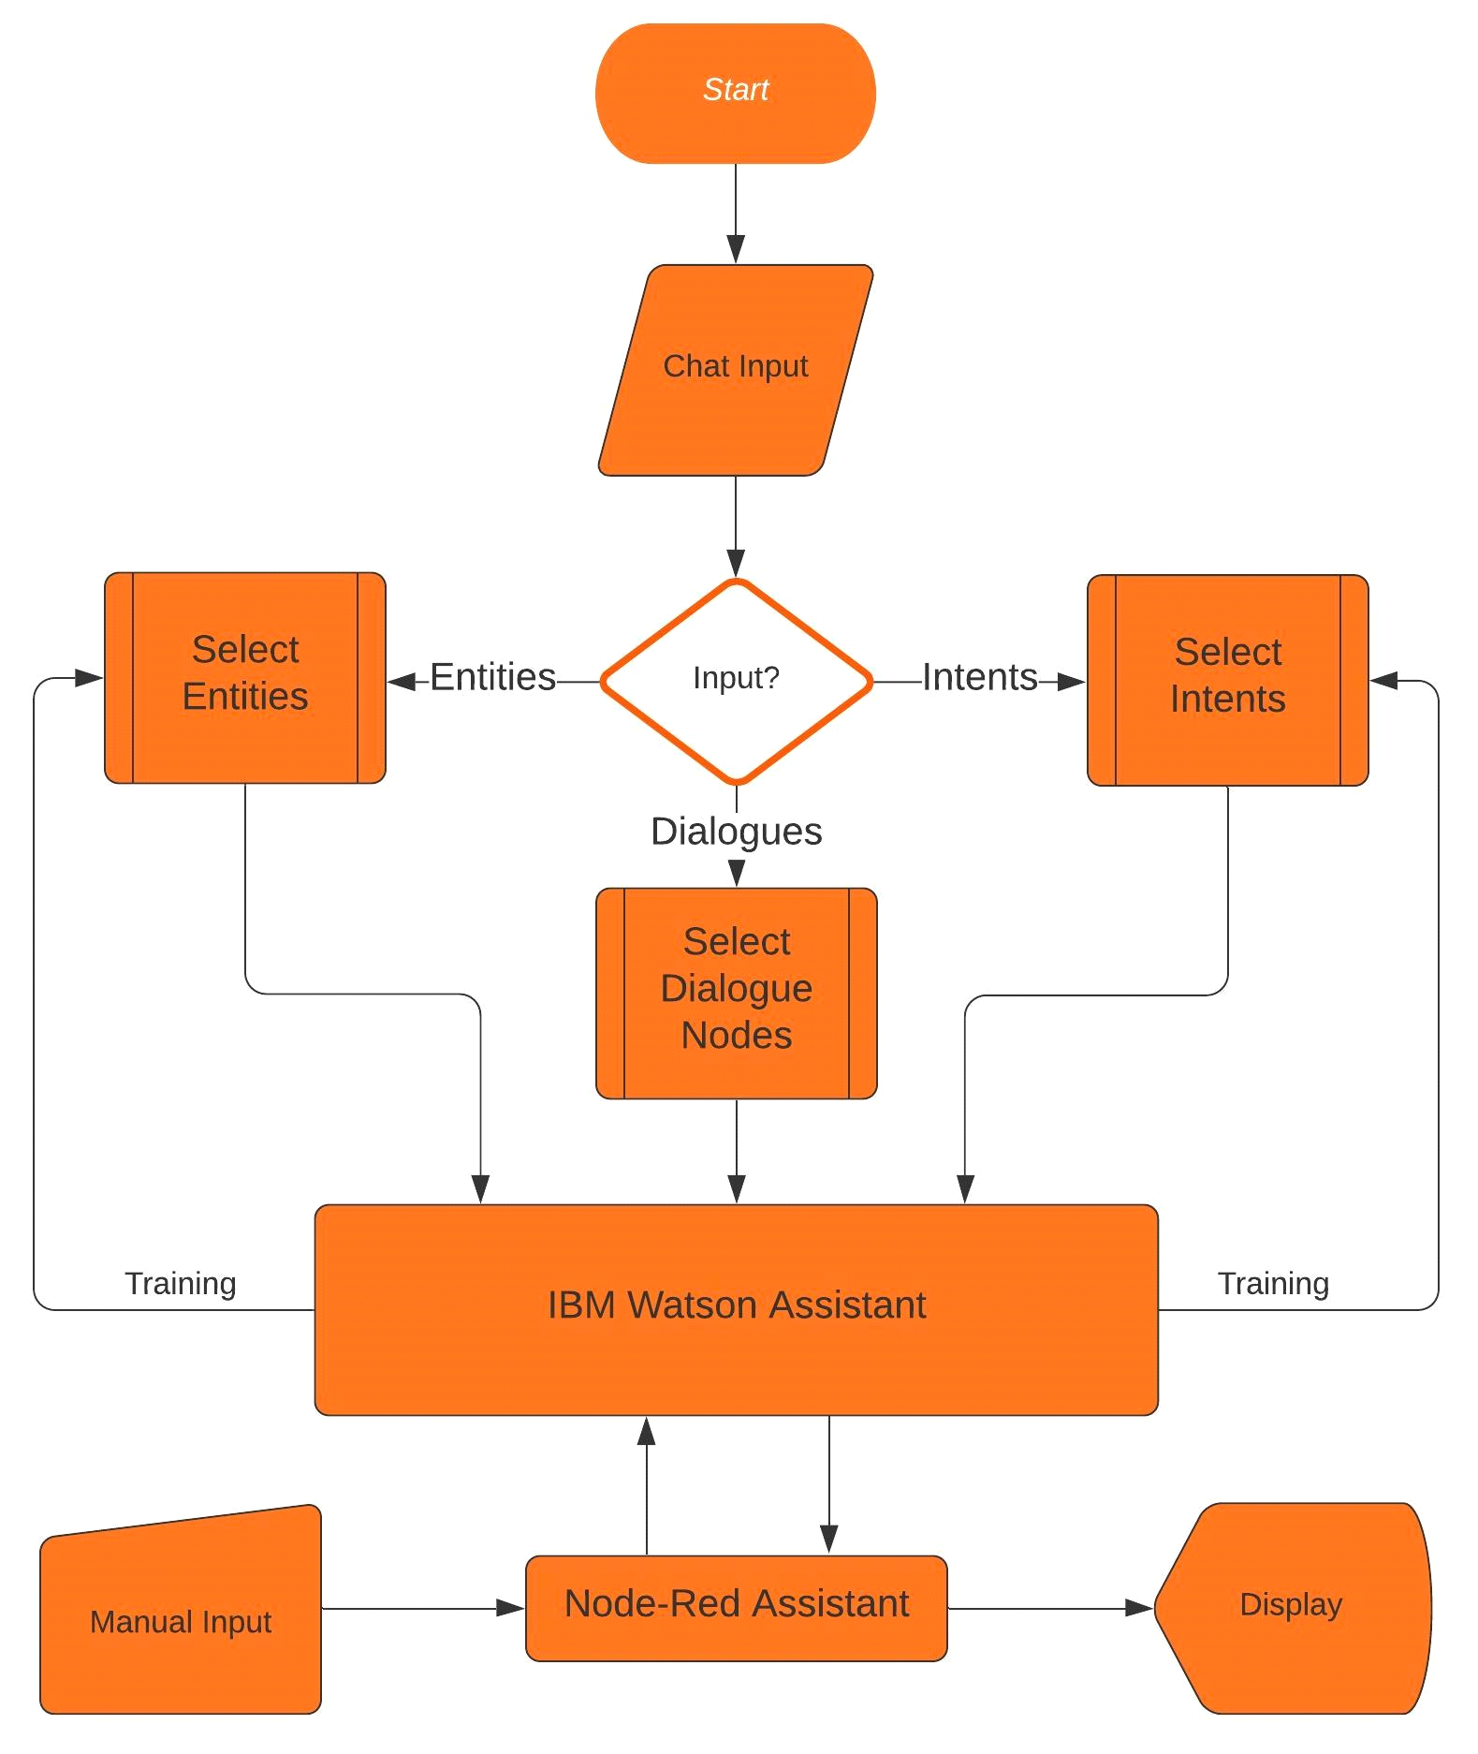

**Node-Red Flow**

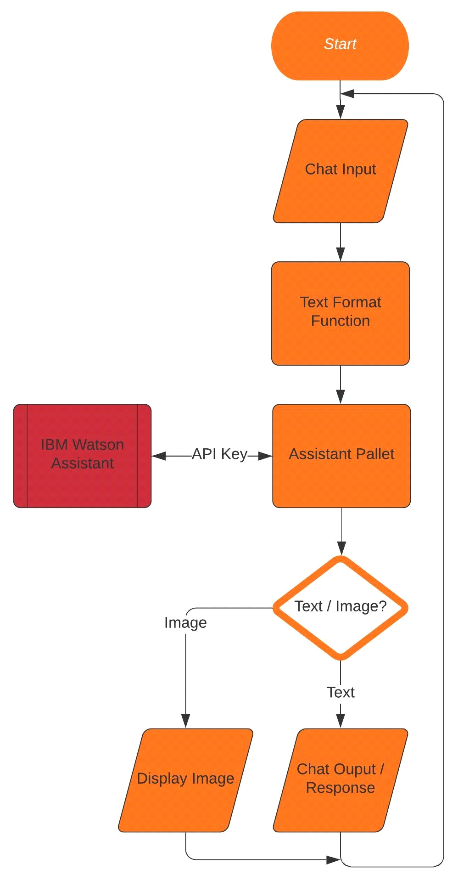

**RESULT**

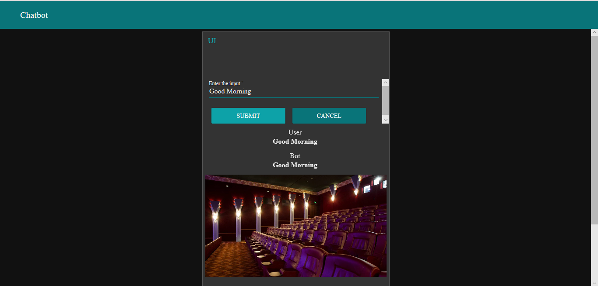

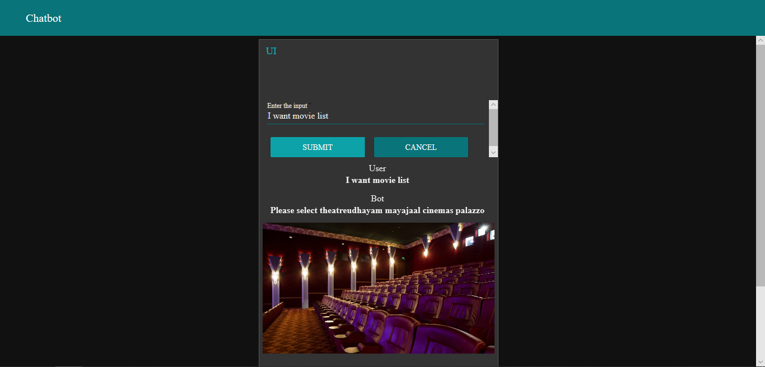

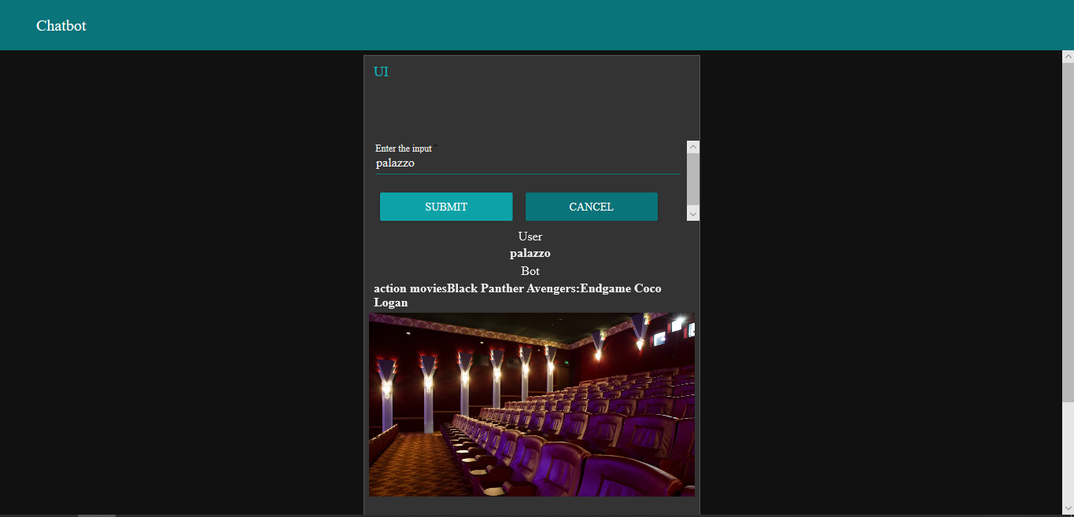

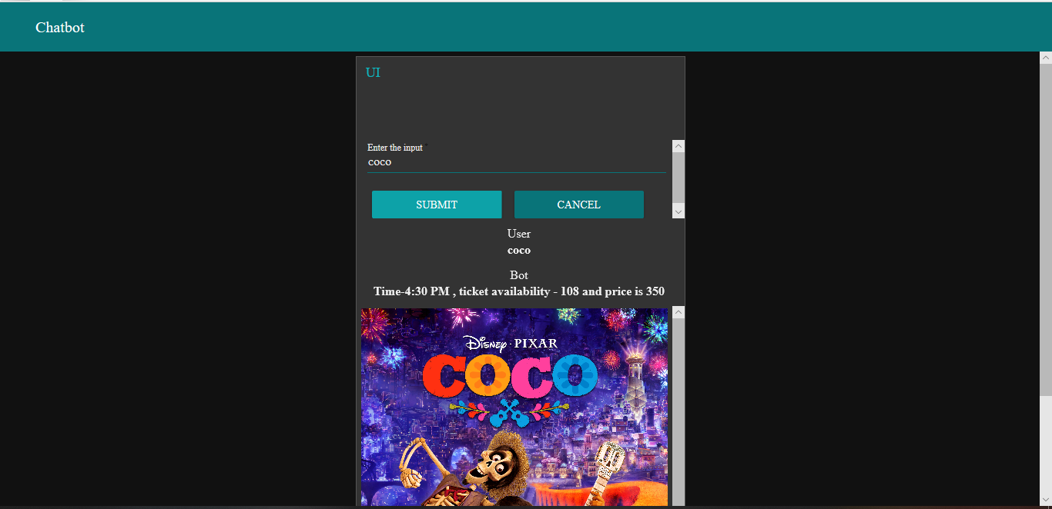

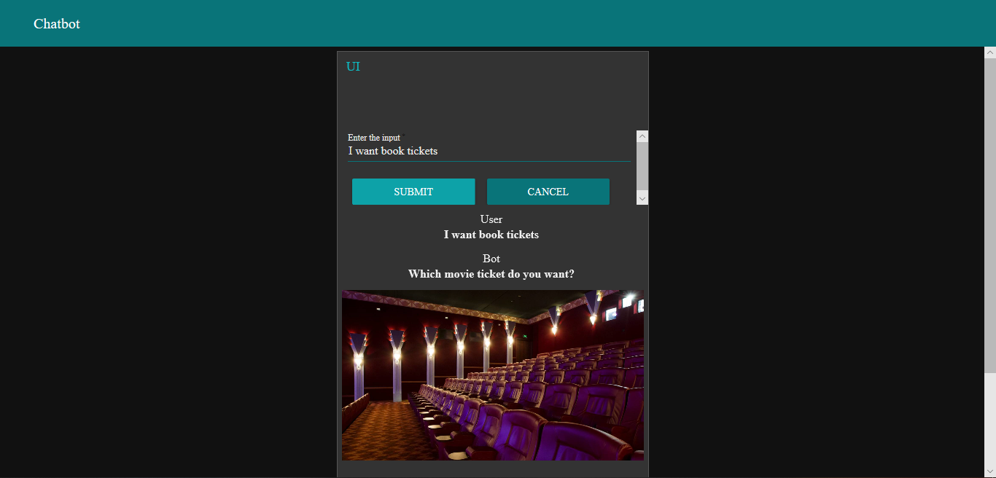

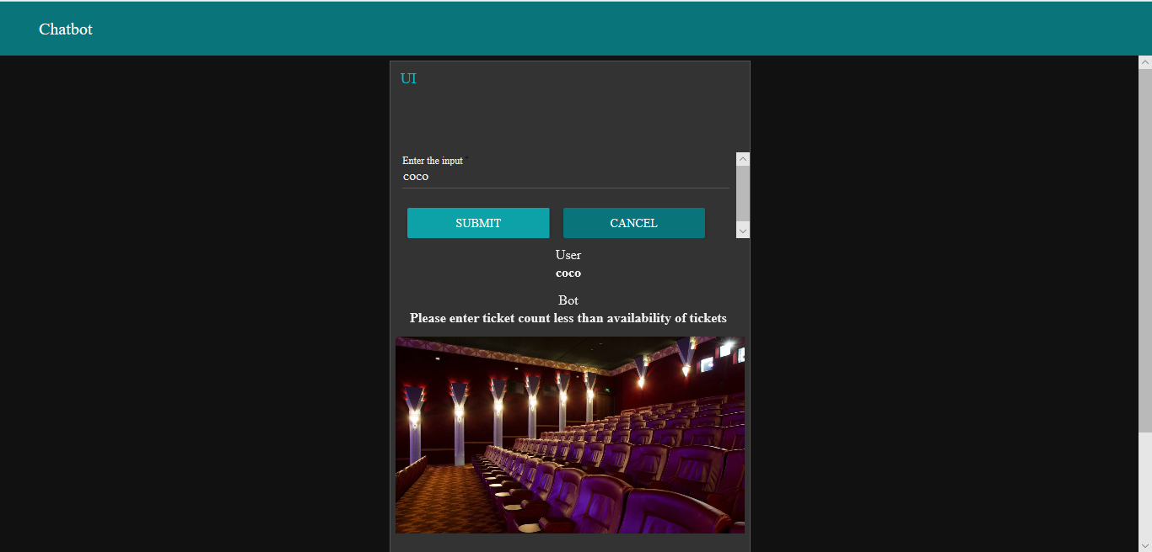

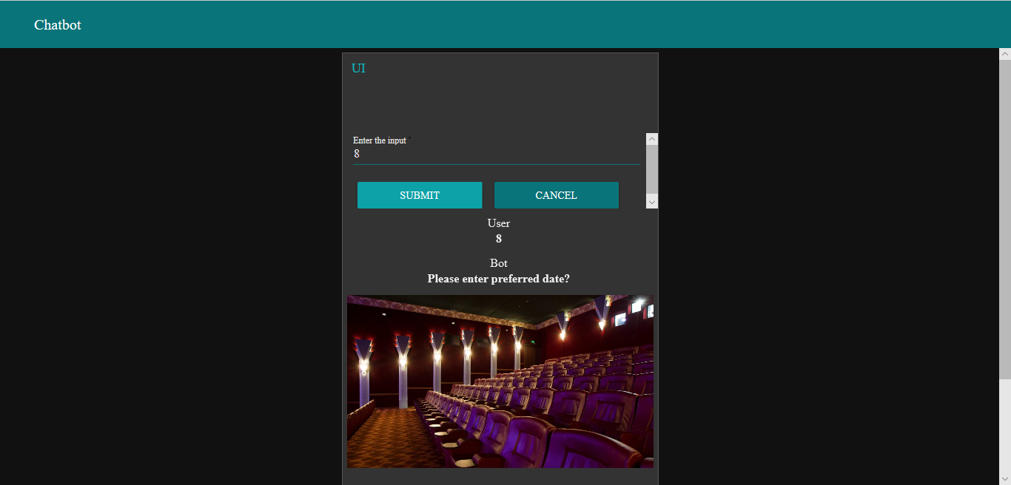

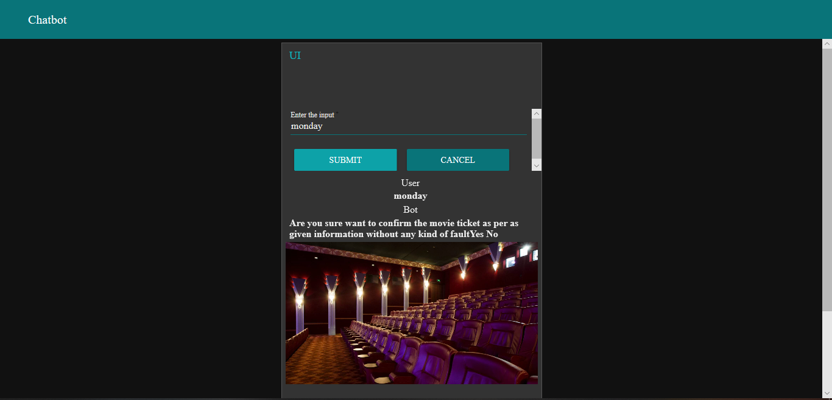



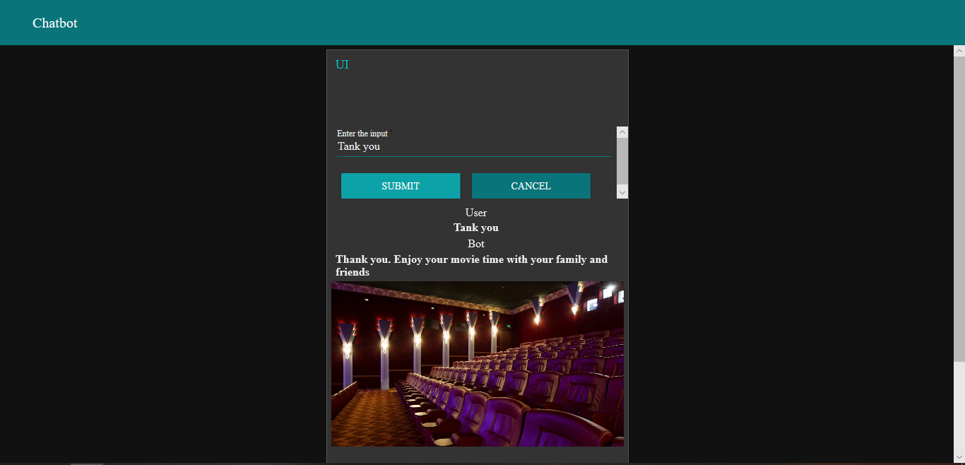

**ADVANTAGES & DISADVANTAGES**

**ADVANTAGES**

* Natural Language interaction
* Auto correct of spelling errors if any
* Automatically trains itself
* Interactive sessions
* Natural Language interaction

**DISADVANTAGES**

* Have to be more specific with the intents and entities
* Little complex in design
* Possibility of error in natural speech recognition
* If any one service fails then the complete system is inoperative

**APPLICATIONS**

* Movie/Shows ticket booking
* Taxi/Bus/Train/Air transport booking
* Appointment booking for Doctors, etc.,
* To place orders in e-commerce sites
* General query resolving of common issues where human interaction is not necessary
* In restaurants to order foods

**CONCLUSION**

Thus, the movie ticketing bot using IBM Watson integrated with Node-Red and got the output. The movie selection, Timing, Payment and seat numbers were selected. The booking was done and the context is cleared. In node red the application has been successfully integrated with the IBM Watson. Got all the outputs generated successfully.

**FUTURE SCOPE**

The chatbots may be designed for Multiple language support for all applications. Maybe configured for Auto searching of data. All services offered by governments shall be integrated under one roof. It can be upgraded as a virtual guide for tourists.

**BIBILOGRAPHY**

[**https://cloud.ibm.com/docs/assistant?topic=assistant-entities**](https://cloud.ibm.com/docs/assistant?topic=assistant-entities)

[**https://youtu.be/6t8C0YRUGec**](https://youtu.be/6t8C0YRUGec)

[**https://youtu.be/anYToBM51uI**](https://youtu.be/anYToBM51uI)

[**https://youtu.be/yAZkeBi5-SY**](https://youtu.be/yAZkeBi5-SY)

[**https://youtu.be/18lVHE7dsRY**](https://youtu.be/18lVHE7dsRY)

[**https://youtu.be/iEadmCNb_hE**](https://youtu.be/iEadmCNb_hE)

[**https://youtu.be/6t8C0YRUGec**](https://youtu.be/6t8C0YRUGec)

[**https://nodered.org/docs/user-guide/editor/workspace/flows**](https://nodered.org/docs/user-guide/editor/workspace/flows)

**APPENDIX**

**Source code**

**IBM Watson:**

{

"intents": [

{

"intent": "Book_tickets",

"examples": [

{

"text": "can you book 4 tickets for me?"

},

{

"text": "can you book tickets for me?"

},

{

"text": "I want to book tickets"

}

],

"description": ""

},

{

"intent": "Enquiry",

"examples": [

{

"text": "can you show maayajaal movie list and their details"

},

{

"text": "can you show palazzo movie list and their details"

},

{

"text": "can you show udhayam movie list and their details"

},

{

"text": "how many tickets are available?"

},

{

"text": "how many tickets are available in mayajaal theater movies and their timings?"

},

{

"text": "how many tickets are available in palazzo theater movies and their timings?"

},

{

"text": "how many tickets are available in udhayam theater movies and their timings?"

},

{

"text": "what is the mayajaal movies timings?"

},

{

"text": "what is the palazzo movies timings?"

},

{

"text": "what is the udhayam movies timings?"

}

],

"description": ""

},

{

"intent": "Greetings",

"examples": [

{

"text": "Good Afternoon"

},

{

"text": "Good Evening"

},

{

"text": "Good Morning"

},

{

"text": "Good Mrng"

},

{

"text": "Hello"

},

{

"text": "Hey"

},

{

"text": "Hi"

}

],

"description": ""

},

{

"intent": "Movies_availability",

"examples": [

{

"text": "can you provide list of movies?"

},

{

"text": "can you provide list of movies with their timings?"

},

{

"text": "can you show me the movie list"

},

{

"text": "can you show me the movie list and their timings?"

},

{

"text": "I want list of movies and their time,price and availability of tickets"

},

{

"text": "I want list of movies and their timings"

},

{

"text": "I want movie list and their details"

},

{

"text": "Please show me the theatres"

},

{

"text": "what are the movies available on Mayajaal cinemas?"

},

{

"text": "what are the movies available on palazzo"

},

{

"text": "what are the movies available on uadhayam?"

}

],

"description": ""

}

],

"entities": [

{

"entity": "Book_tickets",

"values": [

{

"type": "synonyms",

"value": "book",

"synonyms": [

"ticket booking"

]

},

{

"type": "synonyms",

"value": "Book tickets",

"synonyms": []

},

{

"type": "synonyms",

"value": "ticket booking",

"synonyms": []

}

],

"fuzzy_match": true

},

{

"entity": "Confirmation",

"values": [

{

"type": "synonyms",

"value": "Bye",

"synonyms": []

},

{

"type": "synonyms",

"value": "No",

"synonyms": []

},

{

"type": "synonyms",

"value": "Thank you",

"synonyms": [

"Thanks",

"Tq",

"Tqsm"

]

},

{

"type": "synonyms",

"value": "Yes",

"synonyms": []

}

],

"fuzzy_match": true

},

{

"entity": "email",

"values": [

{

"type": "patterns",

"value": "email",

"patterns": [

"\\b([a-zA-Z0-9._-]+@([a-zA-Z0-9_-]+\\.)+[a-zA-Z0-9_-]+)\\b"

]

}

],

"fuzzy_match": true

},

{

"entity": "Enquiry",

"values": [

{

"type": "synonyms",

"value": "Avengers: Endgame",

"synonyms": []

},

{

"type": "synonyms",

"value": "Black Panther",

"synonyms": []

},

{

"type": "synonyms",

"value": "Coco",

"synonyms": []

},

{

"type": "synonyms",

"value": "Elf",

"synonyms": []

},

{

"type": "synonyms",

"value": "Hamilton",

"synonyms": []

},

{

"type": "synonyms",

"value": "Little Women",

"synonyms": []

},

{

"type": "synonyms",

"value": "Logan",

"synonyms": []

},

{

"type": "synonyms",

"value": "Onward",

"synonyms": []

},

{

"type": "synonyms",

"value": "Shirley",

"synonyms": []

},

{

"type": "synonyms",

"value": "Tenet",

"synonyms": []

},

{

"type": "synonyms",

"value": "The Outpost",

"synonyms": []

},

{

"type": "synonyms",

"value": "Tigertail",

"synonyms": []

}

],

"fuzzy_match": true

},

{

"entity": "Greetings",

"values": [

{

"type": "synonyms",

"value": "Good Afternoon",

"synonyms": [

"Gud Aftrn"

]

},

{

"type": "synonyms",

"value": "Good Evening",

"synonyms": [

"Ge",

"Gud Eveg"

]

},

{

"type": "synonyms",

"value": "Good Morning",

"synonyms": [

"Gm",

"Gud Mrg",

"Gud mrg!!"

]

},

{

"type": "synonyms",

"value": "Hello",

"synonyms": [

"hello"

]

},

{

"type": "synonyms",

"value": "Hi",

"synonyms": [

"hey",

"hi"

]

}

],

"fuzzy_match": true

},

{

"entity": "Movies_availability",

"values": [

{

"type": "synonyms",

"value": "mayajaal cinemas",

"synonyms": []

},

{

"type": "synonyms",

"value": "movie list",

"synonyms": [

"availability",

"list",

"movies",

"price",

"shows",

"theatre",

"time"

]

},

{

"type": "synonyms",

"value": "palazzo",

"synonyms": []

},

{

"type": "synonyms",

"value": "udhayam",

"synonyms": []

}

],

"fuzzy_match": true

},

{

"entity": "Payment",

"values": [

{

"type": "synonyms",

"value": "cash",

"synonyms": []

},

{

"type": "synonyms",

"value": "credit card",

"synonyms": []

},

{

"type": "synonyms",

"value": "debit card",

"synonyms": []

},

{

"type": "synonyms",

"value": "UPI",

"synonyms": []

}

],

"fuzzy_match": true

},

{

"entity": "sys-date",

"values": [],

"fuzzy_match": true

},

{

"entity": "sys-number",

"values": [],

"fuzzy_match": true

}

],

"metadata": {

"api_version": {

"major_version": "v2",

"minor_version": "2018-11-08"

},

"from-sample": true

},

"dialog_nodes": [

{

"type": "standard",

"title": "Anything else",

"output": {

"generic": [

{

"values": [

{

"text": "I didn't understand. You can try rephrasing."

},

{

"text": "Can you reword your statement? I'm not understanding."

},

{

"text": "I didn't get your meaning."

}

],

"response_type": "text",

"selection_policy": "sequential"

}

]

},

"conditions": "anything_else",

"dialog_node": "Anything else",

"previous_sibling": "node_3_1609225418376",

"disambiguation_opt_out": true

},

{

"type": "event_handler",

"output": {},

"parent": "slot_9_1609225794214",

"context": {

"Payment": "@Payment"

},

"conditions": "@Payment",

"event_name": "input",

"dialog_node": "handler_10_1609225794344"

},

{

"type": "event_handler",

"title": "handler_10_1609225794344_copy",

"output": {},

"parent": "slot_9_1609225794214_copy",

"context": {

"Payment": "@Payment"

},

"conditions": "@Payment",

"event_name": "input",

"dialog_node": "handler_10_1609225794344_copy"

},

{

"type": "event_handler",

"output": {

"text": {

"values": [

"Please enter ticket count less than availability of tickets"

],

"selection_policy": "sequential"

}

},

"parent": "slot_6_1609233419650",

"event_name": "focus",

"dialog_node": "handler_10_1609233419655",

"previous_sibling": "handler_1_1609233419655"

},

{

"type": "event_handler",

"parent": "node_6_1609151020315",

"event_name": "focus",

"dialog_node": "handler_1_1609151431167"

},

{

"type": "event_handler",

"parent": "node_3_1609225418376",

"event_name": "focus",

"dialog_node": "handler_1_1609225782973",

"previous_sibling": "response_2_1609232582692"

},

{

"type": "event_handler",

"output": {},

"parent": "slot_6_1609233419650",

"context": {

"number": "@sys-number"

},

"conditions": "@sys-number",

"event_name": "input",

"dialog_node": "handler_1_1609233419655"

},

{

"type": "event_handler",

"output": {},

"parent": "slot_3_1609233527989",

"context": {

"date": "@sys-date"

},

"conditions": "@sys-date",

"event_name": "input",

"dialog_node": "handler_1_1609233527993"

},

{

"type": "event_handler",

"output": {

"text": {

"values": [

"We accept only UPI,Credit card,Debit card,Cash"

],

"selection_policy": "sequential"

}

},

"parent": "slot_7_1609233739440",

"event_name": "focus",

"dialog_node": "handler_1_1609233739444",

"previous_sibling": "handler_9_1609233739444"

},

{

"type": "event_handler",

"output": {

"text": {

"values": [

"Please enter preferred date?"

],

"selection_policy": "sequential"

}

},

"parent": "slot_3_1609233527989",

"event_name": "focus",

"dialog_node": "handler_3_1609233527993",

"previous_sibling": "handler_1_1609233527993"

},

{

"type": "event_handler",

"output": {

"text": {

"values": [

"Which movie ticket do you want?"

],

"selection_policy": "sequential"

}

},

"parent": "slot_1_1609151433084",

"event_name": "focus",

"dialog_node": "handler_4_1609151433273",

"previous_sibling": "handler_7_1609151433273"

},

{

"type": "event_handler",

"output": {},

"parent": "slot_6_1609233580368",

"context": {

"emails": "@email"

},

"conditions": "@email",

"event_name": "input",

"dialog_node": "handler_6_1609233580372"

},

{

"type": "event_handler",

"output": {},

"parent": "slot_1_1609151433084",

"context": {

"Enquiry": "@Enquiry"

},

"conditions": "@Enquiry",

"event_name": "input",

"dialog_node": "handler_7_1609151433273"

},

{

"type": "event_handler",

"output": {

"text": {

"values": [

"Please enter your email id"

],

"selection_policy": "sequential"

}

},

"parent": "slot_6_1609233580368",

"context": {

"email": "<? @email.literal ?>"

},

"event_name": "focus",

"dialog_node": "handler_7_1609233580372",

"previous_sibling": "handler_6_1609233580372"

},

{

"type": "event_handler",

"output": {

"generic": [

{

"title": "Is this correct information",

"options": [

{

"label": "Yes",

"value": {

"input": {

"text": "Yes"

}

}

},

{

"label": "No",

"value": {

"input": {

"text": "No"

}

}

}

],

"response_type": "option"

}

]

},

"parent": "slot_9_1609225794214",

"event_name": "focus",

"dialog_node": "handler_9_1609225794344",

"previous_sibling": "handler_10_1609225794344"

},

{

"type": "event_handler",

"title": "handler_9_1609225794344_copy",

"output": {

"generic": [

{

"title": "Is this correct information",

"options": [

{

"label": "Yes",

"value": {

"input": {

"text": "Yes"

}

}

},

{

"label": "No",

"value": {

"input": {

"text": "No"

}

}

}

],

"response_type": "option"

}

]

},

"parent": "slot_9_1609225794214_copy",

"event_name": "focus",

"dialog_node": "handler_9_1609225794344_copy",

"previous_sibling": "handler_10_1609225794344_copy"

},

{

"type": "event_handler",

"output": {},

"parent": "slot_7_1609233739440",

"context": {

"Payment": "@Payment"

},

"conditions": "@Payment",

"event_name": "input",

"dialog_node": "handler_9_1609233739444"

},

{

"type": "standard",

"title": "Enquiry",

"metadata": {

"_customization": {

"mcr": true

}

},

"conditions": "#Enquiry || @Enquiry",

"dialog_node": "node_1_1609051465599",

"previous_sibling": "node_3_1609134107272"

},

{

"type": "standard",

"title": "Greetings",

"metadata": {

"_customization": {

"mcr": true

}

},

"conditions": "#Greetings || @Greetings",

"dialog_node": "node_3_1609047807809",

"previous_sibling": "Welcome"

},

{

"type": "standard",

"title": "Movies availability",

"metadata": {

"_customization": {

"mcr": true

}

},

"conditions": "#Movies_availability || @Movies_availability",

"dialog_node": "node_3_1609134107272",

"previous_sibling": "node_3_1609047807809"

},

{

"type": "standard",

"title": "Confirmation",

"metadata": {

"_customization": {

"mcr": true

}

},

"next_step": {

"behavior": "skip_user_input"

},

"conditions": "@Confirmation",

"dialog_node": "node_3_1609225418376",

"previous_sibling": "node_6_1609151020315"

},

{

"type": "frame",

"title": "Book_tickets",

"output": {

"generic": [

{

"title": "Are you sure want to confirm the movie ticket as per as given information without any kind of fault",

"options": [

{

"label": "Yes",

"value": {

"input": {

"text": "Yes"

}

}

},

{

"label": "No",

"value": {

"input": {

"text": "No"

}

}

}

],

"response_type": "option"

}

]

},

"conditions": "#Book_tickets || @Book_tickets",

"dialog_node": "node_6_1609151020315",

"previous_sibling": "node_1_1609051465599"

},

{

"type": "standard",

"title": "Deleting context variable",

"output": {

"deleted": "<?context.remove('Enquiry')?><?context.remove('number')?><?context.remove('date')?><?context.remove('email')?><?context.remove('Payment')",

"generic": [

{

"values": [],

"response_type": "text",

"selection_policy": "sequential"

}

]

},

"parent": "node_3_1609225418376",

"conditions": "true",

"dialog_node": "node_6_1609232774194"

},

{

"type": "response_condition",

"output": {

"generic": [

{

"title": "Time-4:30 PM , ticket availability - 108 and price is 350",

"source": "https://image.tmdb.org/t/p/original/98G7zRNJBGuJiJmWcCTv0whXltA.jpg",

"response_type": "image"

}

]

},

"parent": "node_1_1609051465599",

"conditions": "@Enquiry:Coco",

"dialog_node": "response_10_1609142886108",

"previous_sibling": "response_9_1609142618250"

},

{

"type": "response_condition",

"output": {

"generic": [

{

"title": "Time-7:30 PM , ticket availability-50 and price is Rs.150",

"source": "https://image.tmdb.org/t/p/original/gGBu0hKw9BGddG8RkRAMX7B6NDB.jpg",

"response_type": "image"

}

]

},

"parent": "node_1_1609051465599",

"conditions": "@Enquiry:Logan",

"dialog_node": "response_10_1609143225043",

"previous_sibling": "response_10_1609142886108"

},

{

"type": "response_condition",

"output": {

"generic": [

{

"values": [

{

"text": "Hello. I am movie ticket booking bot . I'm capable of showing movie list , movie timing , prices and also booking ticket for you. What do you want me to do?"

}

],

"response_type": "text",

"selection_policy": "sequential"

},

{

"values": [],

"response_type": "text",

"selection_policy": "sequential"

},

{

"values": [],

"response_type": "text",

"selection_policy": "sequential"

}

]

},

"parent": "Welcome",

"disabled": true,

"dialog_node": "response_10_1609231721270"

},

{

"type": "response_condition",

"output": {

"generic": [

{

"title": "Good Evening",

"source": "https://resources.stuff.co.nz/content/dam/images/1/j/3/c/7/t/image.related.StuffLandscapeSixteenByNine.1420x800.1j2p2h.png/1494790089373.jpg",

"response_type": "image"

}

]

},

"parent": "node_3_1609047807809",

"conditions": "@Greetings:(Good Evening)",

"dialog_node": "response_1_1609048531948",

"previous_sibling": "response_9_1609048498284"

},

{

"type": "response_condition",

"output": {

"generic": [

{

"title": "Hello",

"source": "https://resources.stuff.co.nz/content/dam/images/1/j/3/c/7/t/image.related.StuffLandscapeSixteenByNine.1420x800.1j2p2h.png/1494790089373.jpg",

"response_type": "image"

}

]

},

"parent": "node_3_1609047807809",

"conditions": "anything_else",

"dialog_node": "response_1_1609048574246",

"previous_sibling": "response_1_1609048531948"

},

{

"type": "response_condition",

"output": {

"generic": [

{

"title": "Time-4:30 PM , ticket availability-80 and price is Rs.450",

"source": "https://www.geekalerts.com/u/Tenet-Movie-Poster.jpg",

"response_type": "image"

}

]

},

"parent": "node_1_1609051465599",

"conditions": "@Enquiry:Tenet",

"dialog_node": "response_1_1609144571812",

"previous_sibling": "response_9_1609144382094"

},

{

"type": "response_condition",

"output": {

"generic": [

{

"values": [

{

"text": "Thank you.Your booking is successful.Please make your payment as soon as possible.Then only your seat will be alloted"

}

],

"response_type": "text",

"selection_policy": "sequential"

}

]

},

"parent": "node_3_1609225418376",

"conditions": "@Confirmation:Yes",

"dialog_node": "response_2_1609231021577",

"previous_sibling": "node_6_1609232774194"

},

{

"type": "response_condition",

"output": {

"generic": [

{

"values": [

{

"text": "Bye. Enjoy your movie time with your family and friends"

}

],

"response_type": "text",

"selection_policy": "sequential"

}

]

},

"parent": "node_3_1609225418376",

"conditions": "@Confirmation:Bye",

"dialog_node": "response_2_1609232582692",

"previous_sibling": "response_9_1609232516237"

},

{

"type": "response_condition",

"output": {

"generic": [

{

"title": "Time-7:30 PM,ticket availability - 300 and price is Rs.250",

"source": "http://i.ebayimg.com/images/i/262145640234-0-1/s-l1000.jpg",

"response_type": "image"

}

]

},

"parent": "node_1_1609051465599",

"conditions": "@Enquiry:Elf",

"dialog_node": "response_3_1609142103430"

},

{

"type": "response_condition",

"output": {

"generic": [

{

"title": "Time-10 AM , ticket availability-100 and price is Rs.300",

"source": "http://pm1.narvii.com/6959/b0a35affb03e376b6abfa711e42bb756ddb3f3f7r1-1463-2048v2_uhq.jpg",

"response_type": "image"

}

]

},

"parent": "node_1_1609051465599",

"conditions": "@Enquiry:Hamilton",

"dialog_node": "response_3_1609143407622",

"previous_sibling": "response_10_1609143225043"

},

{

"type": "response_condition",

"output": {

"generic": [

{

"title": "Time-1:30 PM , ticket availability-78 and price is Rs.450",

"source": "https://fanart.tv/fanart/movies/544415/movieposter/tigertail-5e7eed45da990.jpg",

"response_type": "image"

}

]

},

"parent": "node_1_1609051465599",

"conditions": "@Enquiry:Tigertail",

"dialog_node": "response_3_1609143771982",

"previous_sibling": "response_9_1609143596636"

},

{

"type": "response_condition",

"output": {

"generic": [

{

"title": "Time-7:30 PM , ticket availability-76 and price is Rs.345",

"source": "https://www.geekalerts.com/u/The-Outpost-Poster.jpg",

"response_type": "image"

}

]

},

"parent": "node_1_1609051465599",

"conditions": "@Enquiry:(The Outpost)",

"dialog_node": "response_3_1609144839422",

"previous_sibling": "response_1_1609144571812"

},

{

"type": "response_condition",

"output": {

"generic": [

{

"title": "Good Morning",

"source": "https://resources.stuff.co.nz/content/dam/images/1/j/3/c/7/t/image.related.StuffLandscapeSixteenByNine.1420x800.1j2p2h.png/1494790089373.jpg",

"response_type": "image"

}

]

},

"parent": "node_3_1609047807809",

"conditions": "@Greetings:(Good Morning)",

"dialog_node": "response_5_1609048368900"

},

{

"type": "response_condition",

"output": {

"generic": [

{

"title": "trending movies",

"options": [

{

"label": "Hamilton",

"value": {

"input": {

"text": "Hamilton"

}

}

},

{

"label": "Tigertail",

"value": {

"input": {

"text": "Tigertail"

}

}

},

{

"label": "Shirley",

"value": {

"input": {

"text": "Shirley"

}

}

},

{

"label": "Elf",

"value": {

"input": {

"text": "Elf"

}

}

}

],

"response_type": "option"

}

]

},

"parent": "node_3_1609134107272",

"conditions": "@Movies_availability:(mayajaal cinemas)",

"dialog_node": "response_6_1609134595364",

"previous_sibling": "response_9_1609134239073"

},

{

"type": "response_condition",

"output": {

"generic": [

{

"title": "Time-4:30 PM , ticket availability-120 and price is Rs.450",

"source": "https://i.ebayimg.com/images/i/381216398279-0-1/s-l1000.jpg",

"response_type": "image"

}

]

},

"parent": "node_1_1609051465599",

"conditions": "@Enquiry:Shirley",

"dialog_node": "response_8_1609143777184",

"previous_sibling": "response_3_1609143771982"

},

{

"type": "response_condition",

"output": {

"generic": [

{

"title": "Time-10 AM , ticket availability-308 and price is Rs.200",

"source": "https://i.redd.it/k39doh612d131.jpg",

"response_type": "image"

}

]

},

"parent": "node_1_1609051465599",

"conditions": "@Enquiry:Onward",

"dialog_node": "response_8_1609144178438",

"previous_sibling": "response_8_1609143777184"

},

{

"type": "response_condition",

"output": {

"generic": [

{

"title": "Good Afternoon",

"source": "https://resources.stuff.co.nz/content/dam/images/1/j/3/c/7/t/image.related.StuffLandscapeSixteenByNine.1420x800.1j2p2h.png/1494790089373.jpg",

"response_type": "image"

}

]

},

"parent": "node_3_1609047807809",

"conditions": "@Greetings:(Good Afternoon)",

"dialog_node": "response_9_1609048498284",

"previous_sibling": "response_5_1609048368900"

},

{

"type": "response_condition",

"output": {

"generic": [

{

"title": "thrilling movies",

"options": [

{

"label": "Onward",

"value": {

"input": {

"text": "Onward"

}

}

},

{

"label": "Little Women",

"value": {

"input": {

"text": "Little Women"

}

}

},

{

"label": "Tenet",

"value": {

"input": {

"text": "Tenet"

}

}

},

{

"label": "The Outpost",

"value": {

"input": {

"text": "The Outpost"

}

}

}

],

"response_type": "option"

}

]

},

"parent": "node_3_1609134107272",

"conditions": "@Movies_availability:udhayam",

"dialog_node": "response_9_1609134239073"

},

{

"type": "response_condition",

"output": {

"generic": [

{

"title": "action movies",

"options": [

{

"label": "Black Panther",

"value": {

"input": {

"text": "Black Panther"

}

}

},

{

"label": "Avengers:Endgame",

"value": {

"input": {

"text": "Avengers:Endgame"

}

}

},

{

"label": "Coco",

"value": {

"input": {

"text": "Coco"

}

}

},

{

"label": "Logan",

"value": {

"input": {

"text": "Logan"

}

}

}

],

"response_type": "option"

}

]

},

"parent": "node_3_1609134107272",

"conditions": "@Movies_availability:palazzo",

"dialog_node": "response_9_1609134620564",

"previous_sibling": "response_6_1609134595364"

},

{

"type": "response_condition",

"output": {

"generic": [

{

"title": "Please select theatre",

"options": [

{

"label": "udhayam",

"value": {

"input": {

"text": "udhayam"

}

}

},

{

"label": "mayajaal cinemas",

"value": {

"input": {

"text": "mayajaal cinemas"

}

}

},

{

"label": "palazzo",

"value": {

"input": {

"text": "palazzo"

}

}

}

],

"response_type": "option"

}

]

},

"parent": "node_3_1609134107272",

"conditions": "@Movies_availability:(movie list)",

"dialog_node": "response_9_1609137468697",

"previous_sibling": "response_9_1609134620564"

},

{

"type": "response_condition",

"output": {

"generic": [

{

"title": "Time-10 AM , ticket availability-345 and price Rs.300",

"source": "https://image.tmdb.org/t/p/original/fj7sX7w0MfIxWylcizp5ArPIMFs.jpg",

"response_type": "image"

}

]

},

"parent": "node_1_1609051465599",

"conditions": "@Enquiry:(Black Panther)",

"dialog_node": "response_9_1609142618250",

"previous_sibling": "response_3_1609142103430"

},

{

"type": "response_condition",

"output": {

"generic": [

{

"title": "Time-1:30 PM , ticket availability-250 and price is Rs.175",

"source": "https://insidepulse.com/wp-content/uploads/2019/03/Avengers-Endgame-poster-March-2019-Captain-Marvel-MCU.jpg",

"response_type": "image"

}

]

},

"parent": "node_1_1609051465599",

"conditions": "@Enquiry:(Avengers: Endgame)",

"dialog_node": "response_9_1609143596636",

"previous_sibling": "response_3_1609143407622"

},

{

"type": "response_condition",

"output": {

"generic": [

{

"title": "Time-1:30 PM , ticket availability-458 and price is Rs.350",

"source": "https://www.dvdsreleasedates.com/posters/800/L/Little-Women-2017-movie-poster.jpg",

"response_type": "image"

}

]

},

"parent": "node_1_1609051465599",

"conditions": "@Enquiry:(Little Women)",

"dialog_node": "response_9_1609144382094",

"previous_sibling": "response_8_1609144178438"

},

{

"type": "response_condition",

"output": {

"generic": [

{

"values": [

{

"text": "Please try again with correct information"

}

],

"response_type": "text",

"selection_policy": "sequential"

}

]

},

"parent": "node_3_1609225418376",

"conditions": "@Confirmation:No",

"dialog_node": "response_9_1609232457213",

"previous_sibling": "response_2_1609231021577"

},

{

"type": "response_condition",

"output": {

"generic": [

{

"values": [

{

"text": "Thank you. Enjoy your movie time with your family and friends"

}

],

"response_type": "text",

"selection_policy": "sequential"

}

]

},

"parent": "node_3_1609225418376",

"conditions": "@Confirmation:(Thank you)",

"dialog_node": "response_9_1609232516237",

"previous_sibling": "response_9_1609232457213"

},

{

"type": "slot",

"parent": "node_6_1609151020315",

"variable": "$Enquiry",

"dialog_node": "slot_1_1609151433084",

"previous_sibling": "handler_1_1609151431167"

},

{

"type": "slot",

"parent": "node_6_1609151020315",

"variable": "$date",

"dialog_node": "slot_3_1609233527989",

"previous_sibling": "slot_6_1609233419650"

},

{

"type": "slot",

"parent": "node_6_1609151020315",

"variable": "$number",

"dialog_node": "slot_6_1609233419650",

"previous_sibling": "slot_1_1609151433084"

},

{

"type": "slot",

"output": {},

"parent": "node_6_1609151020315",

"variable": "$emails",

"dialog_node": "slot_6_1609233580368",

"previous_sibling": "slot_3_1609233527989"

},

{

"type": "slot",

"parent": "node_6_1609151020315",

"variable": "$Payment",

"dialog_node": "slot_7_1609233739440",

"previous_sibling": "slot_6_1609233580368"

},

{

"type": "slot",

"output": {},

"parent": "node_3_1609225418376",

"variable": "$Payment",

"dialog_node": "slot_9_1609225794214",

"previous_sibling": "handler_1_1609225782973"

},

{

"type": "slot",

"title": "slot_9_1609225794214_copy",

"output": {},

"parent": "node_3_1609225418376",

"variable": "$Payment",

"dialog_node": "slot_9_1609225794214_copy",

"previous_sibling": "slot_9_1609225794214"

},

{

"type": "standard",

"title": "Welcome",

"output": {

"generic": [

{

"values": [

{

"text": "Hello. I am movie ticket booking bot . I'm capable of showing movie list , movie timing , prices and also booking ticket for you. What do you want me to do?"

}

],

"response_type": "text",

"selection_policy": "sequential"

}

]

},

"metadata": {

"_customization": {

"mcr": false

}

},

"conditions": "welcome",

"dialog_node": "Welcome"

}

],

"counterexamples": [],

"system_settings": {

"off_topic": {

"enabled": true

},

"disambiguation": {

"prompt": "Did you mean:",

"enabled": true,

"randomize": true,

"max_suggestions": 5,

"suggestion_text_policy": "title",

"none_of_the_above_prompt": "None of the above"

},

"system_entities": {

"enabled": true

},

"human_agent_assist": {

"prompt": "Did you mean:"

},

"intent_classification": {

"training_backend_version": "v2"

},

"spelling_auto_correct": true

},

"learning_opt_out": false,

"name": "Movie Ticketing Bot",

"language": "en",

"description": ""

}